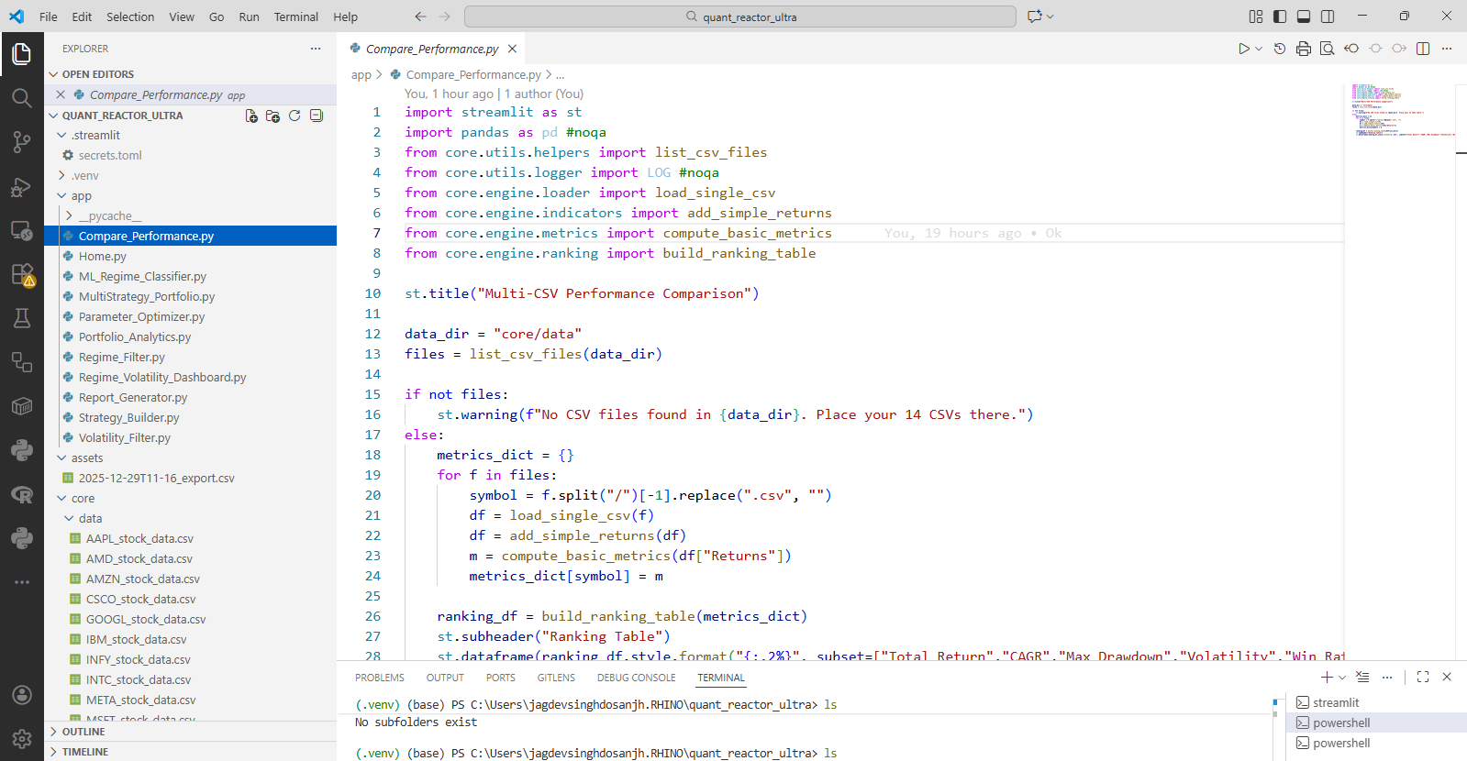
Snapshot One
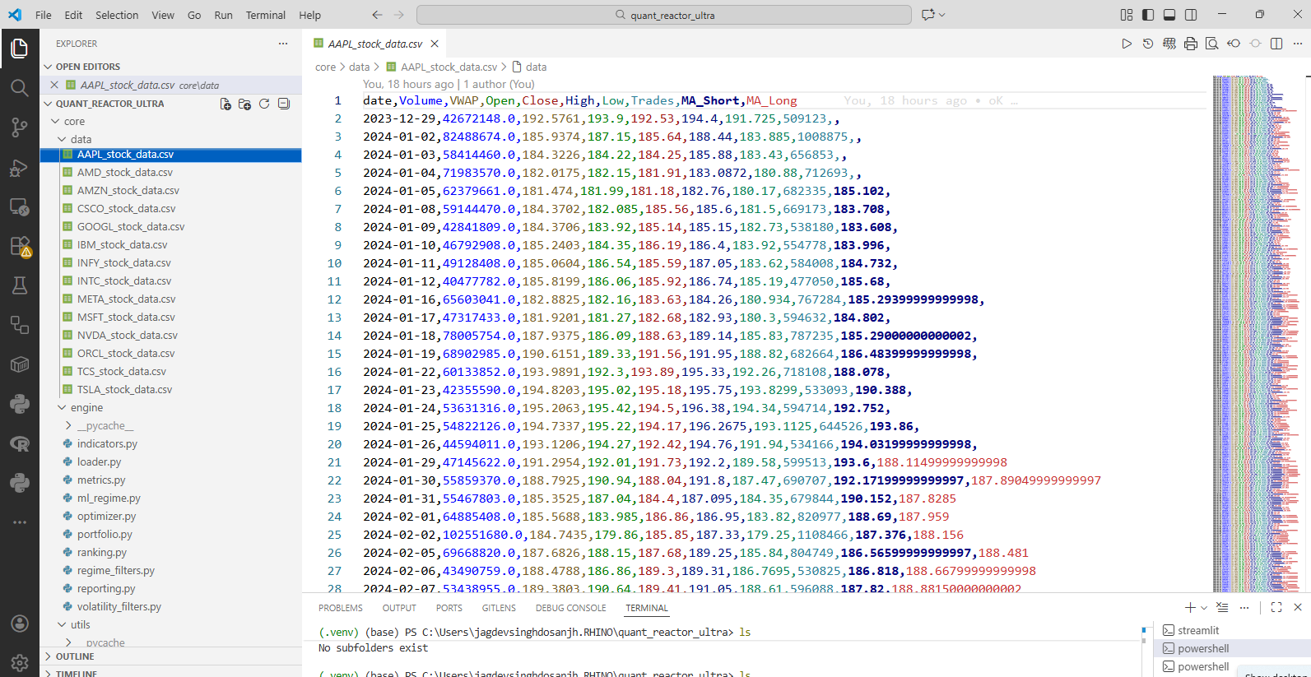
Snapshot 2
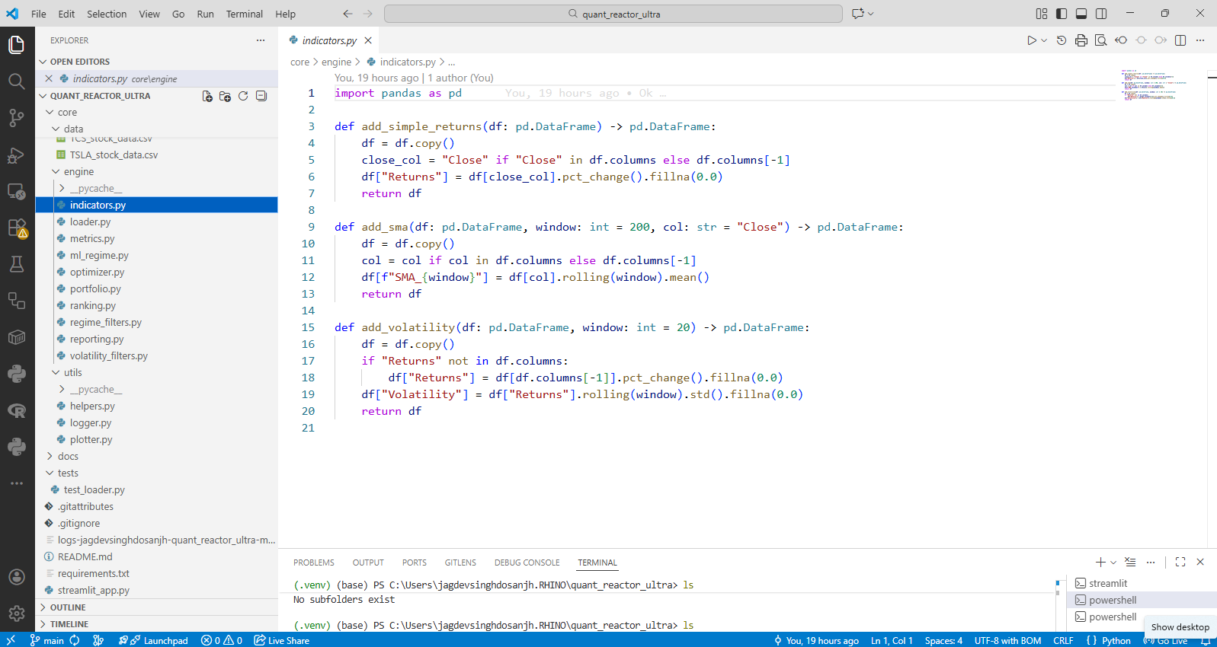
Snapshot 3
Coding Section
#Quant_Reactor_Ultra (VS Code Project using Python and streamlit)
#app/Compare_Performance.py
import streamlit as st
import pandas as pd #noqa
from core.utils.helpers import list_csv_files
from core.utils.logger import LOG #noqa
from core.engine.loader import load_single_csv
from core.engine.indicators import add_simple_returns
from core.engine.metrics import compute_basic_metrics
from core.engine.ranking import build_ranking_table

st.title("Multi-CSV Performance Comparison")

data_dir = "core/data"
files = list_csv_files(data_dir)

if not files:
st.warning(f"No CSV files found in {data_dir}. Place your 14 CSVs there.")
else:
metrics_dict = {}
for f in files:
symbol = f.split("/")[-1].replace(".csv", "")
df = load_single_csv(f)
df = add_simple_returns(df)
m = compute_basic_metrics(df["Returns"])
metrics_dict[symbol] = m

ranking_df = build_ranking_table(metrics_dict)
st.subheader("Ranking Table")
st.dataframe(ranking_df.style.format("{:.2%}", subset=["Total Return","CAGR","Max Drawdown","Volatility","Win Rate","Expectancy","Average R Multiple"]))

-x-
#Quant_Reactor_Ultra (VS Code Project using Python and streamlit)
#app/Home.py
import streamlit as st

st.title("Quant Reactor Ultra")
st.markdown(
'''
Welcome to **Quant Reactor Ultra** your modular lab for:
- Comparing multiple symbols
- Ranking by performance
- Exploring regime and volatility filters
- Building portfolio equity curves
- Studying win-rate, expectancy, and R-multiples
'''
)

-x-
#Quant_Reactor_Ultra (VS Code Project using Python and streamlit)
#app/ML_Regime_Classifier.py
import streamlit as st
import os
from core.utils.helpers import list_csv_files
from core.engine.loader import load_single_csv
from core.engine.indicators import add_simple_returns
from core.engine.ml_regime import train_regime_model, apply_regime_model
from core.utils.plotter import equity_curve_plot

st.title("🤖 ML Regime Classifier")

data_dir = "core/data"
files = list_csv_files(data_dir)

if not files:
st.warning("No CSV files found in core/data")
st.stop()

selected = st.selectbox("Select Symbol", files)
if selected is None:
st.error("No file selected")
st.stop()
selected_str = str(selected)
symbol = os.path.splitext(os.path.basename(selected_str))[0]

df = load_single_csv(selected)
df = add_simple_returns(df)

st.info("Model predicts if next bar's return will be positive (Up/Down regime).")

if st.button("Train Model"):
model, scaler, score, idx = train_regime_model(df)
st.success(f"Out-of-sample accuracy (simple split): {score:.2%}")

df_ml = apply_regime_model(df, model, scaler)

st.subheader("Sample with ML Regime Columns")
st.dataframe(df_ml[["Date", "Returns", "ML_Regime_Prob", "ML_Regime_Up"]].tail())

# Simple ML-based strategy: long when ML_Regime_Up is True
mask = df_ml["ML_Regime_Up"].fillna(False)
rets_ml = df_ml["Returns"].where(mask, 0).fillna(0)
equity_ml = (1 + rets_ml).cumprod()
fig = equity_curve_plot(equity_ml, title=f"{symbol} – ML Regime Strategy Equity")
st.plotly_chart(fig, width="stretch")

-x-
#Quant_Reactor_Ultra (VS Code Project using Python and streamlit)
#app/MultiStrategy_Portfolio.py
import streamlit as st
import pandas as pd
from pathlib import Path
from core.utils.helpers import list_csv_files
from core.engine.loader import load_single_csv
from core.engine.indicators import add_simple_returns
from core.engine.regime_filters import apply_trend_regime
from core.engine.volatility_filters import apply_volatility_filter
from core.utils.plotter import equity_curve_plot

st.title("💼 Multi-Strategy Portfolio Optimizer")
data_dir = "core/data"
files = list_csv_files(data_dir)

if not files:
st.warning("No CSV files found in core/data")
st.stop()

selected = st.selectbox("Select Symbol", files)
if selected is None:
st.warning("No symbol selected.")
st.stop()
# use pathlib to safely get the filename without extension
symbol = Path(selected).stem
symbol = selected.split("/")[-1].replace(".csv", "")

df = load_single_csv(selected)
df = add_simple_returns(df)

sma_window = st.sidebar.slider("SMA Window", 50, 300, 200)
vol_q = st.sidebar.slider("Volatility Quantile", 0.5, 0.95, 0.8)

# Build strategy returns
base = df["Returns"].fillna(0)

df_reg = apply_trend_regime(df.copy(), window=sma_window)
regime = df_reg["Returns"].where(df_reg["Regime_Uptrend"], 0).fillna(0)

df_vol = apply_volatility_filter(df.copy(), quantile=vol_q)
vol = df_vol["Returns"].where(df_vol["Vol_Filter"], 0).fillna(0)

df_both = apply_trend_regime(df.copy(), window=sma_window)
df_both = apply_volatility_filter(df_both, quantile=vol_q)
both = df_both["Returns"].where(df_both["Regime_Uptrend"] & df_both["Vol_Filter"], 0).fillna(0)

st.sidebar.subheader("Strategy Weights")
w_base = st.sidebar.slider("Weight: Baseline", 0.0, 1.0, 0.25, 0.05)
w_reg = st.sidebar.slider("Weight: Regime", 0.0, 1.0, 0.25, 0.05)
w_vol = st.sidebar.slider("Weight: Volatility", 0.0, 1.0, 0.25, 0.05)
w_both = st.sidebar.slider("Weight: Regime + Vol", 0.0, 1.0, 0.25, 0.05)

total_w = w_base + w_reg + w_vol + w_both
if total_w == 0:
st.warning("All weights are zero. Please set at least one non-zero weight.")
else:
w_base /= total_w
w_reg /= total_w
w_vol /= total_w
w_both /= total_w

combined = (
w_base * base +
w_reg * regime +
w_vol * vol +
w_both * both
)

equity = (1 + combined).cumprod()
st.subheader("Combined Strategy Equity Curve")
fig = equity_curve_plot(equity, title=f"{symbol} – Multi-Strategy Portfolio")
st.plotly_chart(fig, width="stretch")

df_out = pd.DataFrame({
"Date": df["Date"],
"Baseline": base,
"Regime": regime,
"Volatility": vol,
"Regime+Vol": both,
"Combined": combined,
})
st.dataframe(df_out.tail())

-x-
#Quant_Reactor_Ultra (VS Code Project using Python and streamlit)
#app/Parameter_Optimizer.py
import streamlit as st
import pandas as pd #NOQA
from core.utils.helpers import list_csv_files
from core.engine.loader import load_single_csv
from core.engine.indicators import add_simple_returns
from core.engine.optimizer import simple_parameter_sweep
from core.engine.metrics import compute_basic_metrics

st.title("🧪 Parameter Optimization")

data_dir = "core/data"
files = list_csv_files(data_dir)

if not files:
st.warning("No CSV files found in core/data")
else:
selected = st.selectbox("Select Symbol", files)
# Guard against selected being None and use os.path.basename for cross-platform paths
if selected:
import os
symbol = os.path.basename(selected).replace(".csv", "")
else:
symbol = ""

if not selected:
st.warning("No symbol selected")
else:
df = load_single_csv(selected)
df = add_simple_returns(df)
returns = df["Returns"]

st.sidebar.subheader("Parameter Grid")

sma_values = st.sidebar.multiselect("SMA Window", [50, 100, 150, 200], default=[100, 200])
vol_q_values = st.sidebar.multiselect("Volatility Quantile", [0.7, 0.8, 0.9], default=[0.8])

param_grid = {
"sma_window": sma_values,
"vol_quantile": vol_q_values,
}

def strategy_fn(df, params):
from core.engine.regime_filters import apply_trend_regime
from core.engine.volatility_filters import apply_volatility_filter

df = apply_trend_regime(df, window=params["sma_window"])
df = apply_volatility_filter(df, quantile=params["vol_quantile"])
mask = df["Regime_Uptrend"] & df["Vol_Filter"]
return df["Returns"].where(mask, 0).fillna(0)

if st.button("Run Optimization"):
results = simple_parameter_sweep(
df,
param_grid,
strategy_fn=strategy_fn,
metric_fn=lambda r: compute_basic_metrics(r)
)

st.subheader("Optimization Results")
st.dataframe(results)

best = results.sort_values("CAGR", ascending=False).iloc[0]
st.success(f"Best Parameters: {best.to_dict()}")

-x-
#Quant_Reactor_Ultra (VS Code Project using Python and streamlit)
#app/Portfolio_Analytics.py
import streamlit as st
from core.utils.helpers import list_csv_files
from core.engine.loader import load_single_csv
from core.engine.indicators import add_simple_returns
from core.engine.portfolio import build_equal_weight_portfolio
from core.utils.plotter import equity_curve_plot

st.title("Portfolio Equity Curve")

data_dir = "core/data"
files = list_csv_files(data_dir)

if not files:
st.warning(f"No CSV files found in {data_dir}.")
else:
returns_dict = {}
for f in files:
symbol = f.split("/")[-1].replace(".csv", "")
df = load_single_csv(f)
df = add_simple_returns(df)
returns_dict[symbol] = df.set_index("Date")["Returns"]

portfolio_df = build_equal_weight_portfolio(returns_dict)

if portfolio_df.empty:
st.warning("Portfolio construction failed (no data).")
else:
st.subheader("Portfolio Equity")
fig = equity_curve_plot(portfolio_df["Portfolio_Equity"], title="Equal-Weight Portfolio Equity")
st.plotly_chart(fig, width="stretch")
st.dataframe(portfolio_df.tail())

-x-
#Quant_Reactor_Ultra (VS Code Project using Python and streamlit)
#app/Regime_Filter.py
import streamlit as st
from core.utils.helpers import list_csv_files
from core.engine.loader import load_single_csv
from core.engine.regime_filters import apply_trend_regime
from core.engine.indicators import add_simple_returns
from core.engine.metrics import compute_basic_metrics
from core.utils.plotter import equity_curve_plot

st.title("📉 Regime Filter Analysis")

data_dir = "core/data"
files = list_csv_files(data_dir)

window = st.sidebar.slider("SMA Window", 50, 300, 200)

if not files:
st.warning("No CSV files found in core/data")
else:
selected = st.selectbox("Select Symbol", files, index=0)
if not selected:
st.warning("No symbol selected")
else:
symbol = selected.split("/")[-1].replace(".csv", "")

df = load_single_csv(selected)
df = add_simple_returns(df)
df = apply_trend_regime(df, window=window)

st.subheader(f"Regime Filter Applied (SMA {window})")
st.dataframe(df.tail())

# Filter returns
filtered_returns = df[df["Regime_Uptrend"]]["Returns"].fillna(0)
metrics = compute_basic_metrics(filtered_returns)

st.subheader("Performance During Uptrend Regime")
st.json(metrics)

# Plot
equity = (1 + filtered_returns).cumprod()
fig = equity_curve_plot(equity, title=f"{symbol} Uptrend Regime Equity Curve")
st.plotly_chart(fig, width="stretch")

-x-
#Quant_Reactor_Ultra (VS Code Project using Python and streamlit)
#app/Regime_Volatility_Dashboard.py
import streamlit as st
import pandas as pd #NOQA
import os
from core.utils.helpers import list_csv_files
from core.engine.loader import load_single_csv
from core.engine.indicators import add_simple_returns
from core.engine.regime_filters import apply_trend_regime
from core.engine.volatility_filters import apply_volatility_filter
from core.engine.metrics import compute_basic_metrics
from core.utils.plotter import equity_curve_plot

st.title("📊 Regime + Volatility Dashboard")

# Resolve data_dir relative to the repository root (app/ -> project root),
# so core/data is found regardless of CWD.
data_dir = os.path.join(os.path.dirname(os.path.dirname(os.path.abspath(__file__))), "core", "data")

files = list_csv_files(data_dir)

if not files:
st.warning("No CSV files found in core/data")
st.stop()

selected = st.selectbox("Select Symbol", files)
if selected is None:
st.warning("No symbol selected")
st.stop()

# use os.path to handle different path separators and safely remove the .csv extension
symbol = os.path.splitext(os.path.basename(selected))[0]
symbol = selected.split("/")[-1].replace(".csv", "")

col1, col2 = st.sidebar.columns(2)
sma_window = col1.slider("SMA Window", 50, 300, 200)
vol_q = col2.slider("Volatility Quantile", 0.5, 0.95, 0.8)

df = load_single_csv(selected)
df = add_simple_returns(df)
df = apply_trend_regime(df, window=sma_window)
df = apply_volatility_filter(df, quantile=vol_q)

st.subheader(f"{symbol} – Filter Masks (tail)")
st.dataframe(df[["Date", "Regime_Uptrend", "Vol_Filter"]].tail())

mask_up = df["Regime_Uptrend"]
mask_low_vol = df["Vol_Filter"]
mask_both = mask_up & mask_low_vol

modes = {
"All Returns": df["Returns"],
"Uptrend Only": df["Returns"].where(mask_up, 0),
"Low Volatility Only": df["Returns"].where(mask_low_vol, 0),
"Uptrend + Low Volatility": df["Returns"].where(mask_both, 0),
}

tab_all, tab_up, tab_vol, tab_both = st.tabs(list(modes.keys()))

for tab, (name, rets) in zip((tab_all, tab_up, tab_vol, tab_both), modes.items()):
with tab:
rets = rets.fillna(0)
metrics = compute_basic_metrics(rets)
equity = (1 + rets).cumprod()
st.markdown(f"### {name}")
st.json(metrics)
fig = equity_curve_plot(equity, title=f"{symbol} – {name}")
st.plotly_chart(fig, width="stretch")

-x-
#Quant_Reactor_Ultra (VS Code Project using Python and streamlit)
#app/Report_Generator.py
import streamlit as st
from core.utils.helpers import list_csv_files
from core.engine.loader import load_single_csv
from core.engine.indicators import add_simple_returns
from core.engine.metrics import compute_basic_metrics
from core.engine.reporting import generate_pdf_report

st.title("📄 PDF Report Generator")

data_dir = "core/data"
files = list_csv_files(data_dir)

if not files:
st.warning("No CSV files found in core/data")
st.stop()

selected = st.selectbox("Select Symbol", files)
if selected is None:
st.warning("No file selected")
st.stop()
symbol = selected.split("/")[-1].replace(".csv", "")

df = load_single_csv(selected)
df = add_simple_returns(df)
metrics = compute_basic_metrics(df["Returns"])

st.subheader("Preview Metrics")
st.json(metrics)

if st.button("Generate PDF Report"):
path = generate_pdf_report(symbol, df, metrics, output_dir="assets")
st.success(f"Report generated: {path}")
with open(path, "rb") as f:
st.download_button(
label="Download PDF",
data=f,
file_name=path.split("/")[-1],
mime="application/pdf",
)

-x-
#Quant_Reactor_Ultra (VS Code Project using Python and streamlit)
#app/Strategy_Builder.py
import os
import streamlit as st
from core.utils.helpers import list_csv_files
from core.engine.loader import load_single_csv
from core.engine.indicators import add_simple_returns
from core.engine.regime_filters import apply_trend_regime
from core.engine.volatility_filters import apply_volatility_filter
from core.engine.metrics import compute_basic_metrics
from core.utils.plotter import equity_curve_plot

st.title("🧱 Strategy Builder")

data_dir = "core/data"
files = list_csv_files(data_dir)

if not files:
st.warning("No CSV files found in core/data")
st.stop()
symbol_file = st.selectbox("Select Symbol", files)
if not symbol_file:
st.warning("No symbol selected")
st.stop()
symbol = os.path.basename(symbol_file)
if symbol.lower().endswith(".csv"):
symbol = symbol[:-4]
symbol = symbol_file.split("/")[-1].replace(".csv", "")

st.sidebar.subheader("Filters")
use_regime = st.sidebar.checkbox("Use Trend Regime Filter", value=True)
use_vol = st.sidebar.checkbox("Use Volatility Filter", value=True)
sma_window = st.sidebar.slider("SMA Window", 50, 300, 200)
vol_quantile = st.sidebar.slider("Volatility Quantile", 0.5, 0.95, 0.8)

df = load_single_csv(symbol_file)
df = add_simple_returns(df)

mask = df["Returns"] == df["Returns"] # start as all True, but avoid .all()
mask = mask.astype(bool)

if use_regime:
df = apply_trend_regime(df, window=sma_window)
mask &= df["Regime_Uptrend"]

if use_vol:
df = apply_volatility_filter(df, quantile=vol_quantile)
mask &= df["Vol_Filter"]

strategy_returns = df["Returns"].where(mask, 0).fillna(0)

metrics = compute_basic_metrics(strategy_returns)
equity = (1 + strategy_returns).cumprod()

st.subheader("Strategy Definition")
st.write(
f"- Symbol: **{symbol}**\n"
f"- Trend filter: **{use_regime}** (SMA {sma_window})\n"
f"- Volatility filter: **{use_vol}** (quantile {vol_quantile})"
)

st.subheader("Performance")
st.json(metrics)

st.subheader("Equity Curve")
fig = equity_curve_plot(equity, title=f"{symbol} – Custom Strategy Equity")
st.plotly_chart(fig, width="stretch")

-x-
#Quant_Reactor_Ultra (VS Code Project using Python and streamlit)
#app/Volatility_Filter.py
import streamlit as st
import os
from core.utils.helpers import list_csv_files
from core.engine.loader import load_single_csv
from core.engine.volatility_filters import apply_volatility_filter
from core.engine.indicators import add_simple_returns
from core.engine.metrics import compute_basic_metrics
from core.utils.plotter import equity_curve_plot

st.title("🌪️ Volatility Filter Analysis")

data_dir = "core/data"
files = list_csv_files(data_dir)

quantile = st.sidebar.slider("Volatility Quantile Threshold", 0.5, 0.95, 0.8)

if not files:
st.warning("No CSV files found in core/data")
selected = st.selectbox("Select Symbol", files)
# ensure selected is not None (selectbox may return None in some contexts)
selected = selected or files[0]
# use os.path to handle different path separators and remove extension safely
symbol = os.path.splitext(os.path.basename(selected))[0]

df = load_single_csv(selected)
df = add_simple_returns(df)
df = apply_volatility_filter(df, quantile=quantile)
df = apply_volatility_filter(df, quantile=quantile)

st.subheader(f"Volatility Filter Applied (Quantile {quantile})")
st.dataframe(df.tail())

filtered_returns = df[df["Vol_Filter"]]["Returns"].fillna(0)
metrics = compute_basic_metrics(filtered_returns)

st.subheader("Performance During Low-Volatility Regime")
st.json(metrics)

equity = (1 + filtered_returns).cumprod()
fig = equity_curve_plot(equity, title=f"{symbol} Low-Volatility Equity Curve")
st.plotly_chart(fig, width="stretch")

-x-
Core / Data Folder with CSV Files inside already shared with you
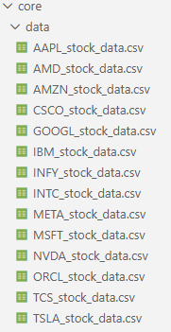
Core/engine Directory code file
#Quant_Reactor_Ultra (VS Code Project using Python and streamlit)
#core/engine/indicators.py
import pandas as pd

def add_simple_returns(df: pd.DataFrame) -> pd.DataFrame:
df = df.copy()
close_col = "Close" if "Close" in df.columns else df.columns[-1]
df["Returns"] = df[close_col].pct_change().fillna(0.0)
return df

def add_sma(df: pd.DataFrame, window: int = 200, col: str = "Close") -> pd.DataFrame:
df = df.copy()
col = col if col in df.columns else df.columns[-1]
df[f"SMA_{window}"] = df[col].rolling(window).mean()
return df

def add_volatility(df: pd.DataFrame, window: int = 20) -> pd.DataFrame:
df = df.copy()
if "Returns" not in df.columns:
df["Returns"] = df[df.columns[-1]].pct_change().fillna(0.0)
df["Volatility"] = df["Returns"].rolling(window).std().fillna(0.0)
return df

-x-
#Quant_Reactor_Ultra (VS Code Project using Python and streamlit)
#core/engine/loader.py
import pandas as pd
from pathlib import Path
from typing import Dict
from core.utils.logger import LOG

def load_single_csv(path: str) -> pd.DataFrame:
# Read CSV with NO assumptions
df = pd.read_csv(path, header=None)

# If all columns are identical (like 'c','c','c'...)
if len(set(df.iloc[0].astype(str))) != len(df.iloc[0]):
# Treat first row as data, not header
df = pd.read_csv(path, header=None)
df.columns = [f"col_{i}" for i in range(df.shape[1])]
else:
# Otherwise treat first row as header
df = pd.read_csv(path)
df.columns = [str(c).strip() for c in df.columns]

# Ensure unique column names
if len(set(df.columns)) != len(df.columns):
df.columns = [f"col_{i}" for i in range(df.shape[1])]

# Detect date column
date_candidates = [c for c in df.columns if "date" in c.lower()]
date_col = date_candidates[0] if date_candidates else df.columns[0]

df[date_col] = pd.to_datetime(df[date_col], errors="coerce")
df = df.dropna(subset=[date_col])
df = df.sort_values(date_col).reset_index(drop=True)
df = df.rename(columns={date_col: "Date"})

return df

def load_all_csvs(data_dir: str) -> Dict[str, pd.DataFrame]:
data_path = Path(data_dir)
if not data_path.exists():
LOG.warning(f"Data directory not found: {data_dir}")
return {}
result = {}
for f in data_path.glob("*.csv"):
try:
df = load_single_csv(str(f))
symbol = f.stem
result[symbol] = df
LOG.info(f"Loaded {symbol} with {len(df)} rows")
except Exception as e:
LOG.error(f"Failed to load {f}: {e}")
return result

-x-
#Quant_Reactor_Ultra (VS Code Project using Python and streamlit)
#core/engine/metrics.py
import pandas as pd
import numpy as np
from typing import Dict

def compute_basic_metrics(returns: pd.Series, freq: int = 252) -> Dict[str, float]:
returns = returns.fillna(0.0)
equity = (1 + returns).cumprod()
total_return = equity.iloc[-1] - 1
cagr = (equity.iloc[-1]) ** (freq / len(equity)) - 1 if len(equity) > 0 else 0.0

dd = (equity.cummax() - equity) / equity.cummax()
max_dd = dd.max() if len(dd) else 0.0

vol = returns.std() * np.sqrt(freq)
sharpe = (returns.mean() * freq) / vol if vol != 0 else 0.0

wins = returns[returns > 0]
losses = returns[returns <= 0]
win_rate = len(wins) / len(returns) if len(returns) else 0.0
avg_win = wins.mean() if len(wins) else 0.0
avg_loss = losses.mean() if len(losses) else 0.0
expectancy = win_rate * avg_win + (1 - win_rate) * avg_loss

avg_r = returns.mean() / returns.std() if returns.std() != 0 else 0.0

return {
"Total Return": float(total_return),
"CAGR": float(cagr),
"Max Drawdown": float(max_dd),
"Volatility": float(vol),
"Sharpe": float(sharpe),
"Win Rate": float(win_rate),
"Expectancy": float(expectancy),
"Average R Multiple": float(avg_r),
}

-x-
#Quant_Reactor_Ultra (VS Code Project using Python and streamlit)
#core/engine/ml_regime.py
import pandas as pd
from sklearn.linear_model import LogisticRegression
from sklearn.model_selection import train_test_split
from sklearn.preprocessing import StandardScaler

def prepare_features(df: pd.DataFrame) -> pd.DataFrame:
df = df.copy()
df["Ret1"] = df["Returns"].shift(1)
df["Ret2"] = df["Returns"].shift(2)
df["Vol10"] = df["Returns"].rolling(10).std()
df["Vol20"] = df["Returns"].rolling(20).std()
df["Target"] = (df["Returns"].shift(-1) > 0).astype(int)
df = df.dropna()
return df

def train_regime_model(df: pd.DataFrame):
df_feat = prepare_features(df)
X = df_feat[["Ret1", "Ret2", "Vol10", "Vol20"]]
y = df_feat["Target"]

scaler = StandardScaler()
X_scaled = scaler.fit_transform(X)

X_train, X_test, y_train, y_test = train_test_split(
X_scaled, y, test_size=0.3, random_state=42, shuffle=False
)

model = LogisticRegression()
model.fit(X_train, y_train)
score = model.score(X_test, y_test)
return model, scaler, score, df_feat.index

def apply_regime_model(df: pd.DataFrame, model, scaler):
df_feat = prepare_features(df)
X = df_feat[["Ret1", "Ret2", "Vol10", "Vol20"]]
X_scaled = scaler.transform(X)
proba = model.predict_proba(X_scaled)[:, 1]
preds = (proba > 0.5).astype(int)

out = df.copy()
out.loc[df_feat.index, "ML_Regime_Prob"] = proba
out.loc[df_feat.index, "ML_Regime_Up"] = preds.astype(bool)
return out

-x-
#Quant_Reactor_Ultra (VS Code Project using Python and streamlit)
#core/engine/optimizer.py
import pandas as pd
from typing import Dict, Callable

def simple_parameter_sweep(
data: pd.DataFrame,
param_grid: Dict[str, list],
strategy_fn: Callable[[pd.DataFrame, Dict], pd.Series],
metric_fn: Callable[[pd.Series], Dict],
):
# Hybrid level: simple, clear, extendable
results = []
from itertools import product
keys = list(param_grid.keys())
for combo in product(*param_grid.values()):
params = dict(zip(keys, combo))
returns = strategy_fn(data, params)
metrics = metric_fn(returns)
row = {**params, **metrics}
results.append(row)
return pd.DataFrame(results)

-x-
#Quant_Reactor_Ultra (VS Code Project using Python and streamlit)
#core/engine/portfolio.py
import pandas as pd

def build_equal_weight_portfolio(returns_dict: dict) -> pd.DataFrame:
if not returns_dict:
return pd.DataFrame()

clean_dict = {}
for name, series in returns_dict.items():
clean_name = str(name).replace(".csv", "").strip()
clean_dict[clean_name] = series.rename(clean_name)

df = pd.concat(clean_dict.values(), axis=1)

df["Portfolio_Return"] = df.mean(axis=1)
df["Portfolio_Equity"] = (1 + df["Portfolio_Return"]).cumprod()

return df

-x-
#Quant_Reactor_Ultra (VS Code Project using Python and streamlit)
#core/engine/ranking.py

import pandas as pd

def build_ranking_table(metrics_dict: dict) -> pd.DataFrame:
if not metrics_dict:
return pd.DataFrame()
df = pd.DataFrame(metrics_dict).T
df.index.name = "Symbol"
df = df.sort_values(by=["CAGR", "Sharpe"], ascending=[False, False])
df["Rank"] = range(1, len(df) + 1)
return df

-x-
#Quant_Reactor_Ultra (VS Code Project using Python and streamlit)
#core/engine/refime_filters.py
import pandas as pd
from .indicators import add_sma

def apply_trend_regime(df: pd.DataFrame, window: int = 200) -> pd.DataFrame:
df = add_sma(df, window=window)
col = "Close" if "Close" in df.columns else df.columns[-2]
df["Regime_Uptrend"] = df[col] > df[f"SMA_{window}"]
return df

-x-
#Quant_Reactor_Ultra (VS Code Project using Python and streamlit)
#core/engine/reporting.py
import matplotlib.pyplot as plt
from matplotlib.backends.backend_pdf import PdfPages
import pandas as pd
from pathlib import Path
from datetime import datetime

def generate_pdf_report(
symbol: str,
df: pd.DataFrame,
metrics: dict,
output_dir: str = "assets"
) -> str:
Path(output_dir).mkdir(parents=True, exist_ok=True)
timestamp = datetime.now().strftime("%Y%m%d_%H%M%S")
filename = f"Report_{symbol}_{timestamp}.pdf"
out_path = str(Path(output_dir) / filename)

with PdfPages(out_path) as pdf:
# Page 1: Title & metrics
fig, ax = plt.subplots(figsize=(8.27, 11.69)) # A4 portrait
ax.axis("off")
text = f"Quant Reactor Ultra Report\n\nSymbol: {symbol}\n\nMetrics:\n"
for k, v in metrics.items():
text += f"- {k}: {v:.4f}\n"
ax.text(0.05, 0.95, text, va="top", fontsize=10)
pdf.savefig(fig)
plt.close(fig)

# Page 2: Equity curve
if "Returns" in df.columns:
equity = (1 + df["Returns"].fillna(0)).cumprod()
fig, ax = plt.subplots(figsize=(8.27, 11.69))
ax.plot(df["Date"], equity)
ax.set_title(f"{symbol} – Equity Curve")
ax.set_xlabel("Date")
ax.set_ylabel("Equity")
pdf.savefig(fig)
plt.close(fig)
return out_path
-x-
#Quant_Reactor_Ultra (VS Code Project using Python and streamlit)
#core/engine/volatility_filters.py
import pandas as pd
from .indicators import add_volatility
def apply_volatility_filter(df: pd.DataFrame, quantile: float = 0.8) -> pd.DataFrame:
df = add_volatility(df)
threshold = df["Volatility"].quantile(quantile)
df["Vol_Filter"] = df["Volatility"] < threshold
return df
-x-
Utils/
#Quant_Reactor_Ultra (VS Code Project using Python and streamlit)
#utils/helpers.py
from pathlib import Path
from typing import List #noqa

def list_csv_files(data_dir: str) -> list:
p = Path(data_dir)
return sorted(str(f) for f in p.glob("*.csv"))

-x-
#Quant_Reactor_Ultra (VS Code Project using Python and streamlit)
#utils/loggers.py
import logging
from pathlib import Path #NOQA

def get_logger(name: str = "quant_reactor_ultra"):
logger = logging.getLogger(name)
if not logger.handlers:
logger.setLevel(logging.INFO)
handler = logging.StreamHandler()
fmt = logging.Formatter("%(asctime)s - %(levelname)s - %(message)s")
handler.setFormatter(fmt)
logger.addHandler(handler)
return logger

LOG = get_logger()

-x-
#Quant_Reactor_Ultra (VS Code Project using Python and streamlit)
#utils/plotter.py
import pandas as pd
import plotly.express as px
import logging
from pathlib import Path #NOQA

def get_logger(name: str = "quant_reactor_ultra"):
logger = logging.getLogger(name)
if not logger.handlers:
logger.setLevel(logging.INFO)
handler = logging.StreamHandler()
fmt = logging.Formatter("%(asctime)s - %(levelname)s - %(message)s")
handler.setFormatter(fmt)
logger.addHandler(handler)
return logger

LOG = get_logger()

def equity_curve_plot(equity: pd.Series, title: str = "Equity Curve"):
fig = px.line(equity, title=title)
fig.update_layout(xaxis_title="Date", yaxis_title="Equity")
return fig

-x-
Root of Directory
#Under root of Project Directory
#streamlit_app.py
import streamlit as st
import importlib
PAGES = {
'Home': 'app.Home',
'Compare Performance': 'app.Compare_Performance',
'Portfolio Analytics': 'app.Portfolio_Analytics',
'Regime Filter': 'app.Regime_Filter',
'Volatility Filter': 'app.Volatility_Filter',
'Parameter Optimization': 'app.Parameter_Optimizer',
'Regime + Vol Dashboard': 'app.Regime_Volatility_Dashboard',
'Strategy Builder': 'app.Strategy_Builder',
'PDF Report Generator': 'app.Report_Generator',
'Multi-Strategy Portfolio': 'app.MultiStrategy_Portfolio',
'ML Regime Classifier': 'app.ML_Regime_Classifier',
}
st.set_page_config(
page_title="Quant Reactor Ultra",
page_icon="📊",
layout="wide",
)
st.header("Welcome to Quant Reactor Ultra - Developed by Jagdev Singh Dosanjh")
st.sidebar.title('Navigation')

choice = st.sidebar.radio('Go to', list(PAGES.keys()))
module_name = PAGES[choice]
module = importlib.import_module(module_name)

-x-
#Project Root
#requirements.txt
pandas
numpy
streamlit
matplotlib
plotly
scikit-learn
-x-
# under .streamlit
#secrets.toml
# DO NOT COMMIT REAL SECRETS TO GITHUB
# This file is ignored by .gitignore

[api_keys]
alpha_vantage = ""
polygon = ""
fmp = ""

[database]
user = ""
password = ""
host = ""
port = ""
database = ""

-x-
# under .gitattributes
* text=auto
*.py text eol=lf
*.toml text eol=lf
*.md text eol=lf

-x-
#under .gitignore
# Python
__pycache__/
*.pyc
*.pyo
*.pyd
*.pkl

# Virtual environments
.venv/
env/
venv/

# Streamlit secrets
.streamlit/secrets.toml

# OS files
.DS_Store
Thumbs.db

# Logs
*.log

# Reports
*.pdf
assets/*.pdf

# Jupyter
.ipynb_checkpoints/

# Cache
.cache/
*.cache

# Large data files (optional)
core/data/*.zip
core/data/*.parquet
core/data/*.xlsx

# VS Code
.vscode/

